EXERCISE 02 :SQL-INDEX

-- Database Schema

CREATE TABLE Customers (

    CustomerID INT PRIMARY KEY,

    Name VARCHAR(100),

    Region VARCHAR(50)

);

CREATE TABLE Products (

    ProductID INT PRIMARY KEY,

    ProductName VARCHAR(100),

    Category VARCHAR(50),

    Price DECIMAL(10, 2)

);

CREATE TABLE Orders (

    OrderID INT PRIMARY KEY,

    CustomerID INT,

    OrderDate DATE,

    FOREIGN KEY (CustomerID) REFERENCES Customers(CustomerID)

);

CREATE TABLE OrderDetails (

    OrderDetailID INT PRIMARY KEY,

    OrderID INT,

    ProductID INT,

    Quantity INT,

    FOREIGN KEY (OrderID) REFERENCES Orders(OrderID),

    FOREIGN KEY (ProductID) REFERENCES Products(ProductID)

);

-- Sample Data

INSERT INTO Customers (CustomerID, Name, Region) VALUES

(1, 'Alice', 'North'),

(2, 'Bob', 'South'),

(3, 'Charlie', 'East'),

(4, 'David', 'West');

INSERT INTO Products (ProductID, ProductName, Category, Price) VALUES

(1, 'Laptop', 'Electronics', 1200.00),

(2, 'Smartphone', 'Electronics', 800.00),

(3, 'Tablet', 'Electronics', 600.00),

(4, 'Headphones', 'Accessories', 150.00);

INSERT INTO Orders (OrderID, CustomerID, OrderDate) VALUES

(1, 1, '2023-01-15'),

(2, 2, '2023-02-20'),

(3, 3, '2023-03-25'),

(4, 4, '2023-04-30');

INSERT INTO OrderDetails (OrderDetailID, OrderID, ProductID, Quantity) VALUES

(1, 1, 1, 1),

(2, 2, 2, 2),

(3, 3, 3, 1),

(4, 4, 4, 3);

-- Exercise 1: Creating a Non-Clustered Index

-- Goal: Create a non-clustered index on the ProductName column in the Products table and compare query execution time before and after index creation.

-- Step 1: Query to fetch product details before index creation

SELECT * FROM Products WHERE ProductName = 'Laptop';

-- Step 2: Create a non-clustered index on ProductName

CREATE NONCLUSTERED Index idx_ProductName ON Products(ProductName);

-- Step 3: Query to fetch product details after index creation

SELECT * FROM Products WHERE ProductName = 'Laptop';

-- 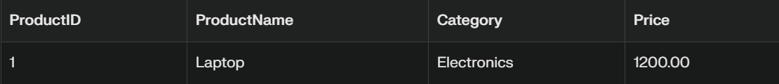

Exercise 2: Creating a Clustered Index

-- Goal: Create a clustered index on the OrderDate column in the Orders table and compare query execution time before and after index creation.

-- Step 1: Query to fetch orders before index creation

SELECT * FROM Orders WHERE OrderDate = '2023-01-15';

-- Step 2: Create a clustered index on OrderDate

Create clustered INDEX idx_OrderDate ON Orders(OrderDate);

-- Step 3: Query to fetch orders after index creation

SELECT * FROM Orders WHERE OrderDate = '2023-01-15';

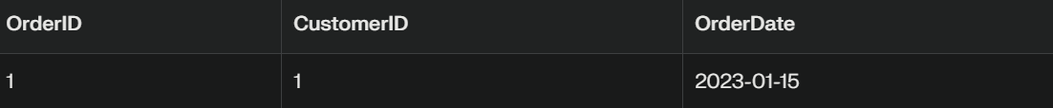

-- Exercise 3: Creating a Composite Index

-- Goal: Create a composite index on the CustomerID and OrderDate columns in the Orders table and compare query execution time before and after index creation.

-- Step 1: Query to fetch orders before index creation

SELECT * FROM Orders WHERE CustomerID = 1 AND OrderDate = '2023-01-15';

-- Step 2: Create a composite index on CustomerID and OrderDate

CREATE NONCLUSTERED INDEX idx_CustomeOrderDate ON Orders(CustomerID,OrderDate);

-- Step 3: Query to fetch orders after index creation

SELECT * FROM Orders WHERE CustomerID = 1 AND OrderDate = '2023-01-15';

